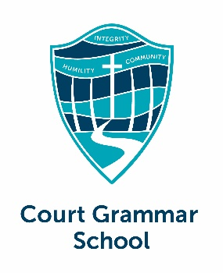 **COURT GRAMMAR SCHOOL**

**BUS WITHDRAWAL FORM**

**2025**

|  |  |
| --- | --- |
| BUS ROUTE  (CGS Buses Only) | BALDIVIS /BALDIVIS Sth / BYFORD / LEDA-ORELIA / SECRET HARBOUR |
| STUDENT NAME | Please accept notification that my child(ren),    Will no longer require the CGS Bus Service. |
| FINISH DATE |  |
| PARENT SIGNATURE / DATE |  |
| CONDITIONS | **FEES ARE APPLICABLE PER TERM.**  Notification of withdrawal prior to commencement of the Term is required |

# **Return form to school administration office**



**OFFICE USE ONLY**

|  |  |
| --- | --- |
| **Student name** |  |
| **Bus Route** | BALDIVIS / BALDIVIS South /BYFORD /  LEDA-ORELIA / SECRET HARBOUR |
|  | Notify Bus Driver.  Amend Bus list records  Enter Finish Date  Notify Finance |